S5P4418 Type Find API for Linux
Version 0.8.0
Copyright © 2014 Nexell Co.,Ltd. All rights reserved.
S5P4418 Type Find API for Linux
Nexell S/W Team 3
Release information
The following changes have been make to this document.
Change History
Date | Change
6 March 2014 | First release for v0.8.0

Proprietary Notice
Information in this document is provided solely to enable system and software implementers to use Nexell products. There are no express or implied copyright licenses granted hereunder to design or fabricate any integrated circuits or integrated circuits based on the information in this document.
Nexell reserves the right to make changes without further notice to any products herein.
Nexell makes no warranty, representation or guarantee regarding the suitability of its products for any particular purpose, nor does Nexell assume any liability arising out of the application or use of any product or circuit, and specifically disclaims any and all liability, including without limitation consequential or incidental damages. “Typical” parameters which may be provided in Nexell data sheets and/or specifications can and do vary in different applications and actual performance may vary over time. All operating parameters, including “Typicals” must be validated for each customer application by customer’s technical experts. Nexell does not convey any license under its patent rights nor the rights of others. Nexell products are not designed, intended, or authorized for use as components in systems intended for surgical implant into the body, or other applications intended to support or sustain life, or for any other application in which the failure of the Nexell product could create a situation where personal injury or death may occur. Should Buyer purchase or use Nexell products for any such unintended or unauthorized application, Buyer shall indemnify and hold Nexell and its officers, employees, subsidiaries, affiliates, and distributors harmless against all claims, costs, damages, and expenses, and reasonable attorney fees arising out of, directly or indirectly, any claim of personal injury or death associated with such unintended or unauthorized use, even if such claim alleges that Nexell was negligent regarding the design or manufacture of the part.

Copyrightⓒ 2009~2014 Nexell Co.,Ltd. All rights reserved.
No part of this publication may be reproduced, stored in a retrieval system, or transmitted in any form or by any means, electric or mechanical, by photocopying, recording, or otherwise, without the prior written consent of Nexell.

Contact us
[463-825] Bundang yemizi Bldg. 1202, 6-5 Sunae-dong, Bundang-gu, Sungnam-city, Gyeonggi-do, Korea.
TEL: 82-31-698-7400
FAX:82-31-698-7455
http://www.nexell.co.kr

Contents
Chap 1. Overview 1
1.1 Overview 1
1.2 Environment 1
Chap 2. APIs 2
2.1 Overview 2
2.2 API Details 2
Chap 3. Example 4
3.1 Bolck Diagram 4
Chap 4. 지원 범위 5
4.1 지원 가능한 format. 5
Chap 5. Annex 7
Annex A (informative) 7

Overview

Overview
이 문서는 S5P4418 Linux 환경에서 각종 동영상 및 음악 파일의 media information 에 대한 API의 사용법을 설명한 문서이다.

Environment
이 API의 동작 환경은 다음과 같다.
- S5P4418 D/Q
- Linux Kernel Version 3.4.5+
- G-Streamer 0.10 Plug-In 포함된 root file system.
- G-Streamer video decoder plug-In
  - “libgstnxvideodec.so”
- G-Streamer video sink Plug-In
  - “libgstnxvideosink.so”
- Video en/decoder firmware & library.
  - “nx_vpu.ko”
  - “libnxvpu.so”
- ION memory allocator library.
  - “libnxvmem.so”
- V4L2 device driver & related libraries.
  - “libnxv4l2.so”
  - “libnxdsp.so”

APIs

Overview
API 에 대한 세부 설명이다.

API Details

NX_TypeFind_Open
Description:
This function creates the memory,initializes the handle.
Prototype:
MP_RESULT handle NX_MPOpen(TYMEDIA_INFO **ty_handle);
Parameters;
TYMEDIA_INFO **ty_handle:
Return value:
Error Code (output)
.

enum{
ERROR_NONE = 0,
ERROR = -1,
ERROR_HANDLE = -2,
ERROR_NOT_SUPPORT_CONTENTS = -3
}; //ErrorCode

NX_TypeFind_Close
Description:
This function frees the memory.
Prototype:
void NX_TypeFind_Close(TYMEDIA_INFO *ty_handle );
Parameters:
TYMEDIA ty_handle: TypeFind handle (input/output)
Return value:
None.

NX_TypeFind
Description: Media Information
This function gets media information.
Prototype:
MP_RESULT_NX_TypeFind(
TYMEDIA_INFO *ty_media_handle, (output)
Const char *uri (input)
)
Parameters:
TYMEDIA_INFO ty_media_handle: TypeFind handler.
Const char uri : file uri.
Return value:
If exist Media information for each indexes, return ERROR_NONE. Otherwise return ERROR.

typedef struct TYMEDIA_INFO {
int AudioOnly;
int VideoOnly;
int AudioOn;
int VideoOn;
int DemuxType;
unsigned long AudioTrackTotNum;
AUDIO_INFO AudioInfo[MEDIA_MAX];
unsigned long VideoTrackTotNum;
VIDEO_INFO VideoInfo[MEDIA_MAX];
} TYMEDIA_INFO;

Example

Bolck Diagram

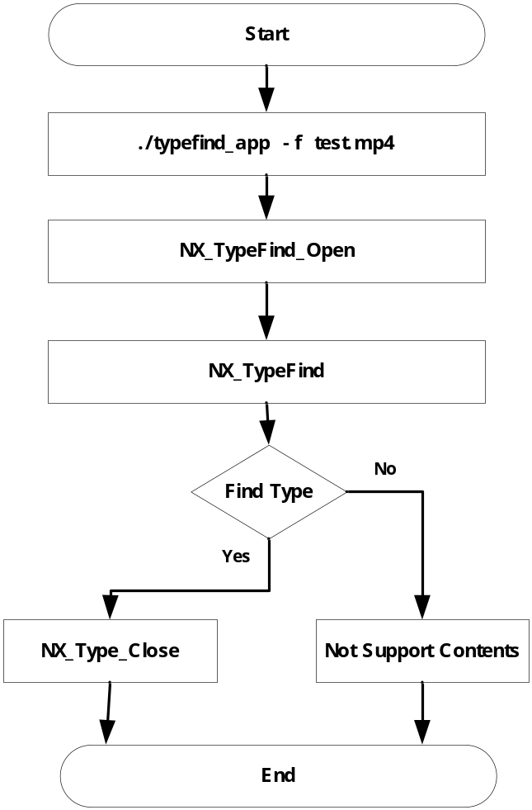
그림 1. Example Block Diagram
그림 1 은 example 에 대한 설명이다.
- Typefind_app -f test.mp4 명령어를 실행한다.
- 지원하지 않는 codec type 이면 Error 를 발생한다.

지원 범위

지원 가능한 format.

Container Types
Container | Support
ASF | O
AVI | O
MKV | O
MP4 | O
OGG | O
RM(RealMdeia) | O
FLV | O
MPEG-PS | O
MPEG-TS | X(향후 지원)

Video Codec Types
Video Decoder | Support
H.264 | O
H.263 | O
MPEG4 | O
FLV | O
RealVideo | O
MPEG4-ASP (include XVID) | O
VC1(WMV9) | O
Theora | O
MPEG2 | O

Audio Codec Types
Audio Decoder | Support
MP3 | O
AAC | O
AC3 | O
OGG | O
RealAudio | O
WMA | O
FLAC | O

Audio Player Codec Types
Audio Decoder | Support
MP3 | O
OGG | O
AAC | O
WAV | O
WMA | O
FLAC | O

Annex

Annex A (informative)

Change history
Change history
Date | Subject/Comment | Old | New
2014-03 | 1.Add Container Type MPEG-TS  2.Add Audio Codec Type WMA  3.Add Audio Codec Type FLAC  4.Add Audio Codec Type Real-Audio | 0.8.0 | 0.9.0
2014-03 | Typefind API for Linux |  | 0.8.0

